Catch the Brain Waves to Success using Brain Based Learning
What we know . . .
Matters  Do you believe you can do it? | _________________ Matters | learn how to block your  A______________  N______________  T_____________S
I am ___________ | 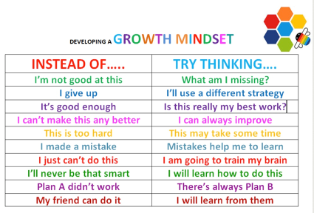 | 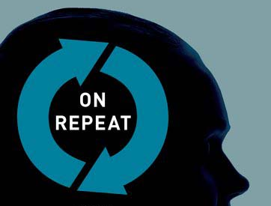  Repeat to __________  ___________ to repeat
First Meeting:
Teach students _________ the brain learns and that they can _______ their brain.
Helpful Question: What is your intention?
The brain finds what it’s looking for.
Lesson should begin with an intention.
When students write down _________ and _________ they’re
going to do the assignment, they are more like to do it.
Appropriate arousal is essential for learning. Are you alert and attentive?
What are the best and worst study strategies?

_______________________________________________________
Myths proliferate
Imagine having a brain that is only 10% active, that shrinks when you drink less than 6 to 8 glasses of water a day. . .
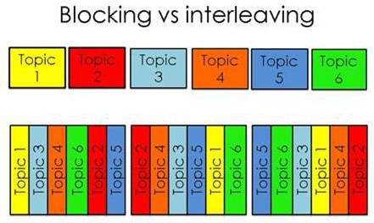
So, some thoughts on interleaving….
- “Research shows unequivocally that mastery and long-term retention are much better if you interleave practice than if you mass it.”
- Scatter common problem types throughout your teaching.
- Mix up the topics.

Avoid distractions. Avoid asking students to multitask.
(Don’t use completely auditory &or completely visual pathways)
Learning should:
- Make connections (Schema –a definition, a diagram, plan, or scheme.)
- Activate the right pathway (plans)
- Wire & Fire (Dendrites & Synapses)
- Realize if there is an inadequate neural network and attempt to build it.
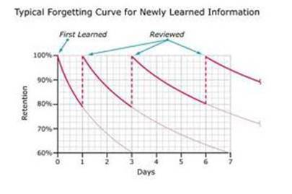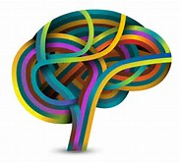__________________
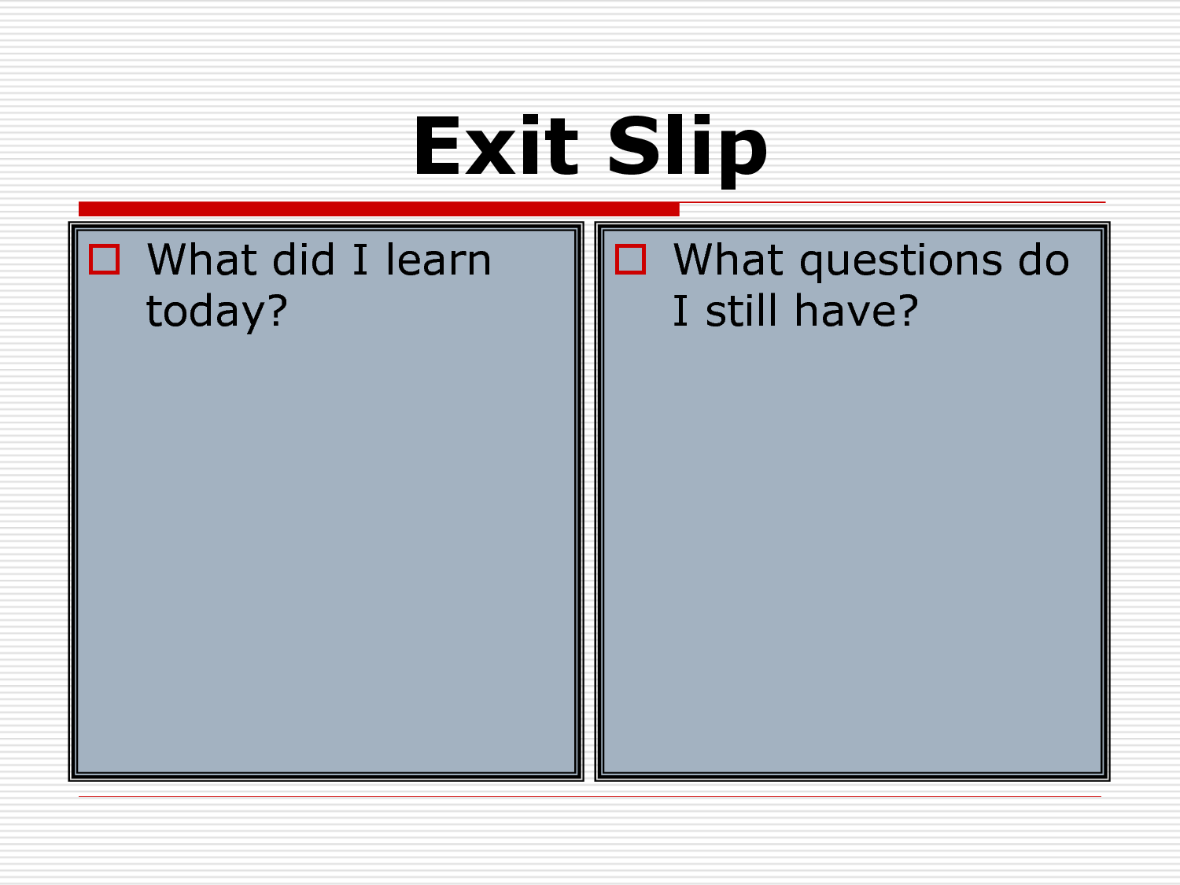
Things that increase the cognitive load | -increased stress and anxiety  -hunger  -fatigue  -a large amount of information being processed
Things that decrease the cognitive load | -automaticity  -planning  -routinization  -distance from task/material
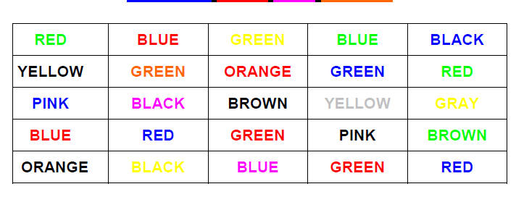

What happens when a student has reached maximum cognitive capacity?
When a learner has reached his or her cognitive capacity at any given time, he or she is saturated. When saturated, the brain cannot easily process any more information. Time is required for saturation to decrease.

The basic idea of cognitive load theory is that cognitive capacity in working memory is limited, so that if a learning task requires too much capacity, learning will be hampered. A heavy cognitive load = mental fatigue.
Helpful Links
http://www.brainfacts.org/educators/educator-resources/articles-folder/2016/the-truth-behind-brain-based-learning-051916/ [Play video – Neuromyths]
Neuroscience and How Students Learn
http://gsi.berkeley.edu/gsi-guide-contents/learning-theory-research/neuroscience/
How Students Learn
http://gsi.berkeley.edu/gsi-online-library/how-students-learn/
Daniela Kaufer: What can Neuroscience Research Teach Us about Teaching?
http://gsi.berkeley.edu/programs-services/hsl-project/hsl-speakers/kaufer/
John F. Kihlstrom: How Students Learn -- and How We Can Help Them
http://socrates.berkeley.edu/~kihlstrm/GSI_2011.htm

Stroop Effect http://faculty.washington.edu/chudler/words.html#seffect

http://www.socrative.com/
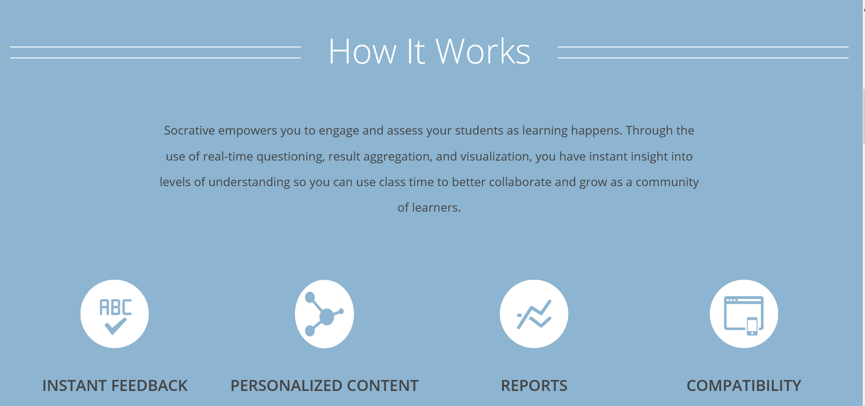
Notes

