To View a Problem Solving Session:
- Click the hyperlink to the Google Drive 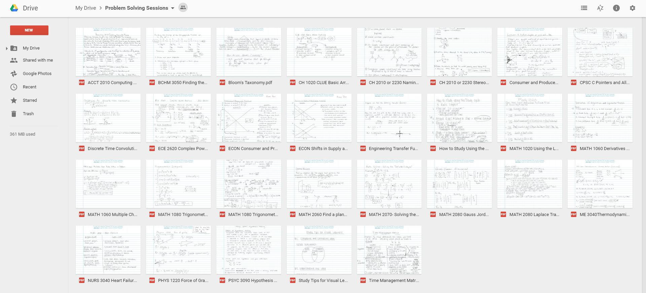

- Click the problem you are interested in downloading, which should pop up on your screen with the text “To hear and view this Pencast PDF on your computer, click her to get the latest version of Adobe Reader.” 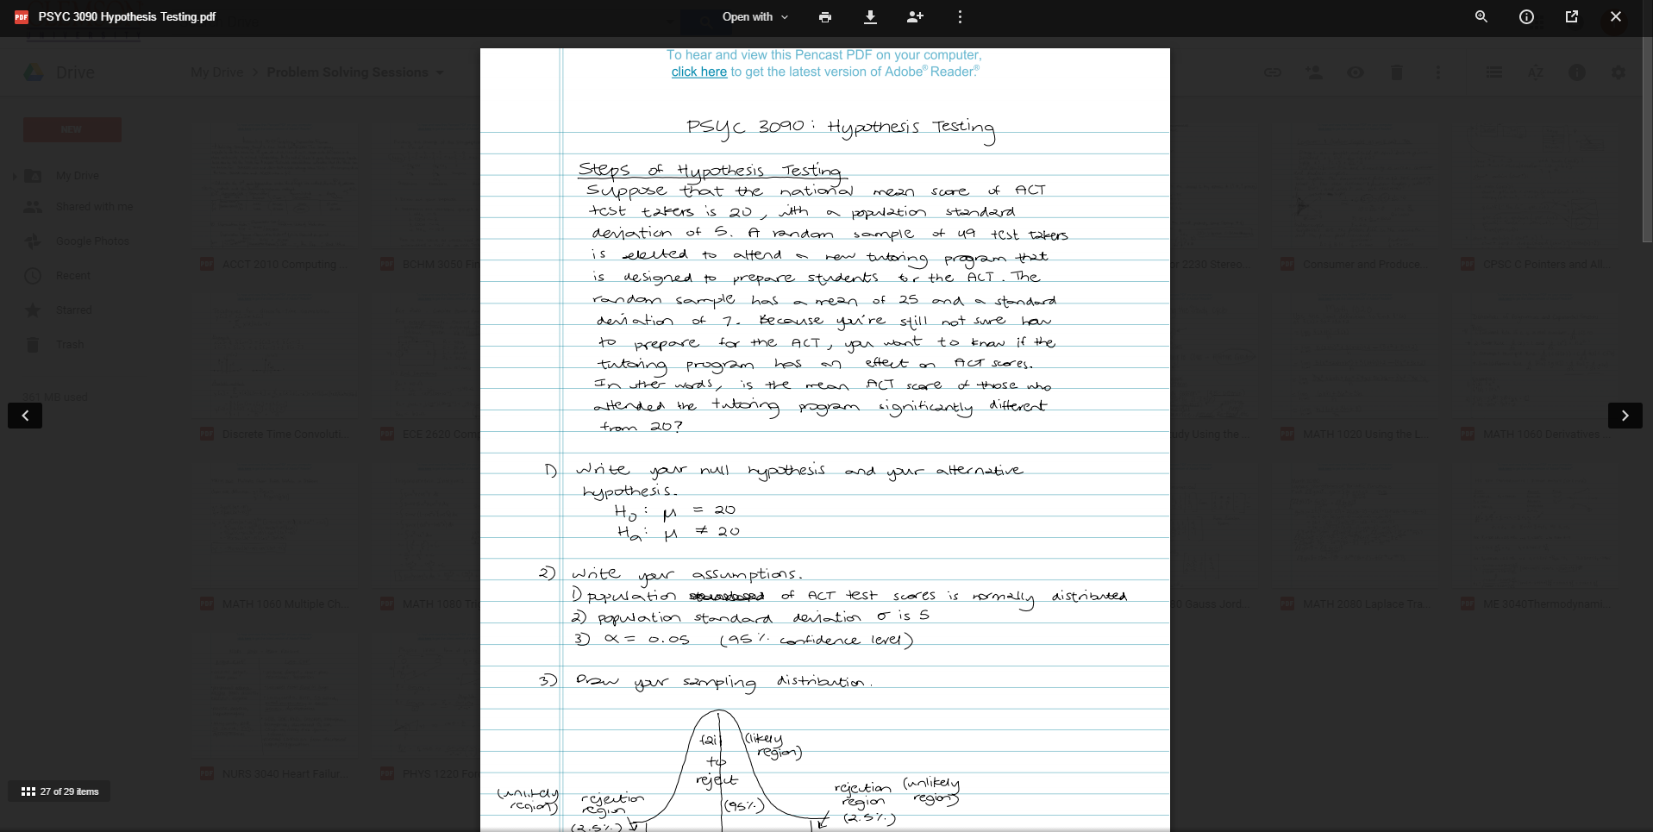

- If you do not have the latest version of Adobe Reader, click “click here” to start the download process.

- If you do, click the download button at the top middle which looks like:

- The download should show up. DO NOT open the download. Instead, open it in a folder and then open the pdf so that the pdf will open in Adobe, not in your internet browser window.

- For windows, click the drop-down arrow by the download at the bottom of the screen and choose “Show in folder.”

- Double click the pdf to open and view it as a pencast! You should now have sound.
